Sprint 0 Report
Zihao Wang

GitHub Repository:
https://github.com/Charles-oak/cs449-peg-solitaire

1. Key Decisions of the Solitaire Project
Topic | Decision
Object-oriented programming language | Python
GUI library | Tkinter
IDE | PyCharm
xUnit framework | Python unittest
Programming style guide | Google Python Style Guide
Project hosting site | Github.com
Other decisions if applicable

2. Unit Testing
Framework: Python unittest
Tutorial: Python unittest documentation

Execution screenshot：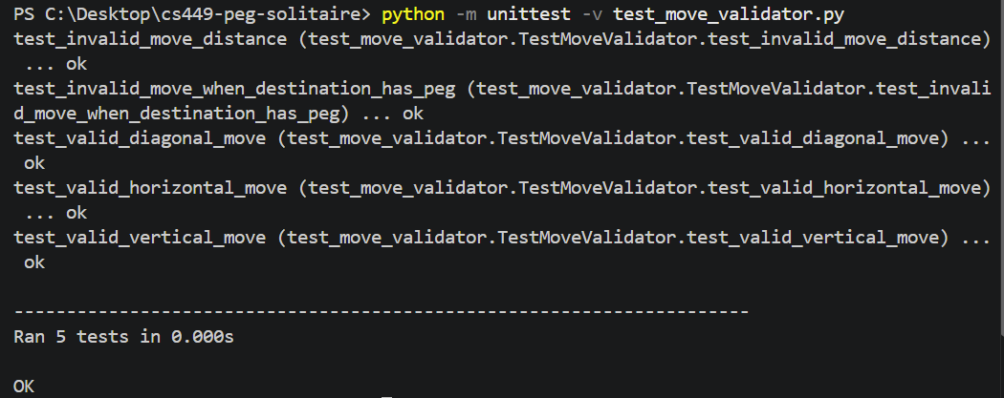

Source code:
move_validator.py:
class MoveValidator:
"""Checks whether a move in Peg Solitaire is valid."""

@staticmethod
def get_middle_position(start, end):
"""Return the position jumped over, or None for invalid geometry."""
start_row, start_col = start
end_row, end_col = end

row_difference = abs(end_row - start_row)
col_difference = abs(end_col - start_col)

valid_move = (
(row_difference == 2 and col_difference == 0)
or (row_difference == 0 and col_difference == 2)
or (row_difference == 2 and col_difference == 2)
)

if not valid_move:
return None

middle_row = (start_row + end_row) // 2
middle_col = (start_col + end_col) // 2

return middle_row, middle_col

@classmethod
def is_valid_move(cls, board, start, end):
"""Check the geometry and board state of a move."""
middle = cls.get_middle_position(start, end)

if middle is None:
return False

if start not in board or middle not in board or end not in board:
return False

start_has_peg = board[start]
middle_has_peg = board[middle]
destination_is_empty = not board[end]

return start_has_peg and middle_has_peg and destination_is_empty

test_move_validator.py：
import importlib.util
import unittest
from pathlib import Path

MOVE_VALIDATOR_PATH = Path(r"C:\Desktop\move_validator.py")
spec = importlib.util.spec_from_file_location("external_move_validator", MOVE_VALIDATOR_PATH)
move_validator = importlib.util.module_from_spec(spec)
assert spec.loader is not None
spec.loader.exec_module(move_validator)
MoveValidator = move_validator.MoveValidator

class TestMoveValidator(unittest.TestCase):

def setUp(self):
self.board = {
(0, 0): True,
(0, 1): True,
(0, 2): False,
(1, 0): True,
(1, 1): True,
(1, 2): True,
(2, 0): False,
(2, 1): True,
(2, 2): False,
}

def test_valid_horizontal_move(self):
self.assertTrue(
MoveValidator.is_valid_move(self.board, (0, 0), (0, 2))
)

def test_valid_vertical_move(self):
self.assertTrue(
MoveValidator.is_valid_move(self.board, (0, 0), (2, 0))
)

def test_valid_diagonal_move(self):
self.assertTrue(
MoveValidator.is_valid_move(self.board, (0, 0), (2, 2))
)

def test_invalid_move_when_destination_has_peg(self):
self.assertFalse(
MoveValidator.is_valid_move(self.board, (2, 1), (0, 1))
)

def test_invalid_move_distance(self):
self.assertFalse(
MoveValidator.is_valid_move(self.board, (0, 0), (1, 1))
)

if __name__ == "__main__":
unittest.main()

3. GUI Programming

Execution screenshot：
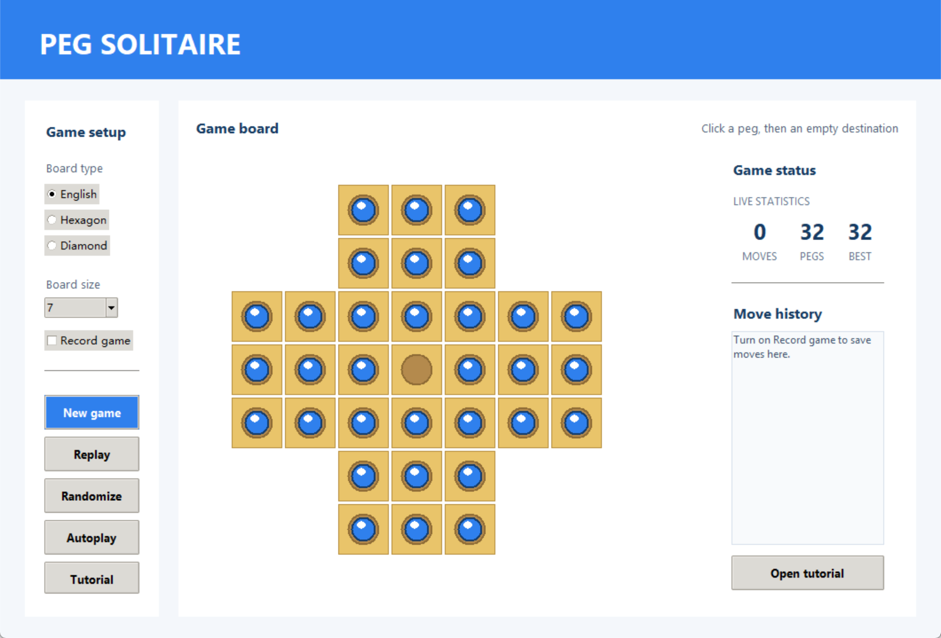
Source code:
solitaire_gui.py:
"""An interactive Peg Solitaire GUI for the CS 449 project.

Click a peg, then click an empty hole two spaces away to make a move.
"""

import random
import tkinter as tk
from tkinter import messagebox, ttk

class SolitaireGUI:
"""Provide a playable, polished Tkinter interface for Peg Solitaire."""

BACKGROUND = "#f4f7fb"
NAVY = "#173b62"
BLUE = "#2f80ed"
GOLD = "#f4b942"
BOARD = "#e9c46a"
HOLE = "#b48a4d"

def __init__(self, root):
self.root = root
self.root.title("Peg Solitaire | CS 449")
self.root.geometry("1060x720")
self.root.minsize(920, 650)
self.root.configure(bg=self.BACKGROUND)

self.board_type = tk.StringVar(value="English")
self.board_size = tk.IntVar(value=7)
self.record_game = tk.BooleanVar(value=False)
self.status = tk.StringVar()
self.moves_var = tk.StringVar(value="0")
self.pegs_var = tk.StringVar(value="0")
self.best_var = tk.StringVar(value="--")
self.selected = None
self.move_count = 0
self.autoplay_job = None
self.board = {}
self.cell_bounds = {}
self.recorded_moves = []

self._configure_styles()
self._build_layout()
self.new_game()

def _configure_styles(self):
style = ttk.Style()
style.theme_use("clam")
style.configure("Card.TFrame", background="white")
style.configure("Title.TLabel", background=self.BLUE, foreground="white",
font=("Segoe UI", 24, "bold"))
style.configure("Section.TLabel", background="white", foreground=self.NAVY,
font=("Segoe UI", 12, "bold"))
style.configure("Metric.TLabel", background="white", foreground=self.NAVY,
font=("Segoe UI", 19, "bold"))
style.configure("MetricName.TLabel", background="white", foreground="#63758b",
font=("Segoe UI", 9))
style.configure("Info.TLabel", background="white", foreground="#506176",
font=("Segoe UI", 10))
style.configure("Action.TButton", font=("Segoe UI", 10, "bold"), padding=(12, 8))
style.configure("Primary.TButton", background=self.BLUE, foreground="white",
font=("Segoe UI", 10, "bold"), padding=(12, 8))
style.map("Primary.TButton", background=[("active", "#1769cf")])

def _build_layout(self):
header = tk.Frame(self.root, bg=self.BLUE, height=90)
header.pack(fill="x")
header.pack_propagate(False)
ttk.Label(header, text="PEG SOLITAIRE", style="Title.TLabel").pack(
anchor="w", padx=42, pady=24
)

content = tk.Frame(self.root, bg=self.BACKGROUND)
content.pack(fill="both", expand=True, padx=28, pady=24)
content.grid_columnconfigure(1, weight=1)
content.grid_rowconfigure(0, weight=1)

controls = ttk.Frame(content, style="Card.TFrame", padding=22)
controls.grid(row=0, column=0, sticky="nsw", padx=(0, 22))
self._build_controls(controls)

board_card = ttk.Frame(content, style="Card.TFrame", padding=18)
board_card.grid(row=0, column=1, sticky="nsew")
board_card.grid_rowconfigure(1, weight=1)
board_card.grid_columnconfigure(0, weight=1)
board_card.grid_columnconfigure(1, minsize=220)
top = tk.Frame(board_card, bg="white")
top.grid(row=0, column=0, columnspan=2, sticky="ew", pady=(0, 10))
ttk.Label(top, text="Game board", style="Section.TLabel").pack(side="left")
ttk.Label(top, text="Click a peg, then an empty destination", style="Info.TLabel").pack(side="right")
self.canvas = tk.Canvas(board_card, bg="white", highlightthickness=0, cursor="hand2")
self.canvas.grid(row=1, column=0, sticky="nsew")
self.canvas.bind("<Button-1>", self.on_board_click)
self._build_game_info(board_card)

footer = tk.Frame(self.root, bg=self.BACKGROUND)
footer.pack(fill="x", padx=42, pady=(0, 18))
tk.Label(footer, textvariable=self.status, bg=self.BACKGROUND, fg="#4b6078",
font=("Segoe UI", 10)).pack(side="left")
tk.Label(footer, text="Tip: a legal jump crosses exactly one peg.", bg=self.BACKGROUND,
fg="#78879a", font=("Segoe UI", 10)).pack(side="right")

def _build_controls(self, parent):
ttk.Label(parent, text="Game setup", style="Section.TLabel").pack(anchor="w")
ttk.Label(parent, text="Board type", style="Info.TLabel").pack(anchor="w", pady=(18, 5))
for name in ("English", "Hexagon", "Diamond"):
ttk.Radiobutton(parent, text=name, value=name, variable=self.board_type,
command=self.new_game).pack(anchor="w", pady=3)

ttk.Label(parent, text="Board size", style="Info.TLabel").pack(anchor="w", pady=(18, 5))
size_menu = ttk.Combobox(parent, textvariable=self.board_size, state="readonly",
values=(5, 7, 9), width=9)
size_menu.pack(anchor="w")
size_menu.bind("<<ComboboxSelected>>", lambda _event: self.new_game())
ttk.Checkbutton(parent, text="Record game", variable=self.record_game,
command=self.refresh_move_history).pack(
anchor="w", pady=(14, 0)
)

ttk.Separator(parent, orient="horizontal").pack(fill="x", pady=22)
ttk.Button(parent, text="New game", style="Primary.TButton", command=self.new_game).pack(fill="x", pady=4)
ttk.Button(parent, text="Replay", style="Action.TButton", command=self.replay).pack(fill="x", pady=4)
ttk.Button(parent, text="Randomize", style="Action.TButton", command=self.randomize).pack(fill="x", pady=4)
self.autoplay_button = ttk.Button(parent, text="Autoplay", style="Action.TButton",
command=self.toggle_autoplay)
self.autoplay_button.pack(fill="x", pady=4)
ttk.Button(parent, text="Tutorial", style="Action.TButton", command=self.show_tutorial).pack(
fill="x", pady=4
)

def _build_game_info(self, parent):
"""Use the space beside the board for game status and recorded moves."""
panel = ttk.Frame(parent, style="Card.TFrame", padding=(18, 12))
panel.grid(row=1, column=1, sticky="nsew", padx=(12, 0))
ttk.Label(panel, text="Game status", style="Section.TLabel").pack(anchor="w")
ttk.Label(panel, text="LIVE STATISTICS", style="MetricName.TLabel").pack(
anchor="w", pady=(14, 4)
)
metric_row = tk.Frame(panel, bg="white")
metric_row.pack(fill="x")
for value, label in ((self.moves_var, "MOVES"), (self.pegs_var, "PEGS"), (self.best_var, "BEST")):
item = tk.Frame(metric_row, bg="white")
item.pack(side="left", expand=True, fill="x")
ttk.Label(item, textvariable=value, style="Metric.TLabel").pack()
ttk.Label(item, text=label, style="MetricName.TLabel").pack()

ttk.Separator(panel, orient="horizontal").pack(fill="x", pady=20)
ttk.Label(panel, text="Move history", style="Section.TLabel").pack(anchor="w")
self.history_list = tk.Listbox(panel, height=10, bg="#f8fafc", fg="#40546b",
font=("Segoe UI", 9), relief="flat", highlightthickness=1,
highlightbackground="#d7e0eb", selectbackground=self.BLUE)
ttk.Button(panel, text="Open tutorial", style="Action.TButton", command=self.show_tutorial).pack(
fill="x", side="bottom", pady=(12, 0)
)
self.history_list.pack(fill="both", expand=True, pady=(8, 0))

def show_tutorial(self):
"""Show the concise game instructions in a separate dialog."""
messagebox.showinfo(
"Peg Solitaire Tutorial",
"1. Select a blue peg.\n\n"
"2. Click an empty hole exactly two spaces away.\n\n"
"3. The peg between them is removed.\n\n"
"Goal: finish with one peg remaining."
)

def refresh_move_history(self):
"""Refresh the right-side move history panel."""
self.history_list.delete(0, tk.END)
if not self.record_game.get():
self.history_list.insert(tk.END, "Turn on Record game to save")
self.history_list.insert(tk.END, "moves here.")
elif not self.recorded_moves:
self.history_list.insert(tk.END, "No moves recorded yet.")
else:
for move in self.recorded_moves:
self.history_list.insert(tk.END, move)
self.history_list.see(tk.END)

def valid_positions(self):
size = self.board_size.get()
center = size // 2
positions = set()
for row in range(size):
for col in range(size):
if self.board_type.get() == "English":
arm = center - 1
valid = arm <= row <= size - arm - 1 or arm <= col <= size - arm - 1
elif self.board_type.get() == "Hexagon":
q, r = col - center, row - center
valid = max(abs(q), abs(r), abs(-q - r)) <= center
else:
valid = abs(row - center) + abs(col - center) <= center
if valid:
positions.add((row, col))
return positions

def new_game(self):
self.stop_autoplay()
positions = self.valid_positions()
center = (self.board_size.get() // 2, self.board_size.get() // 2)
self.board = {position: position != center for position in positions}
self.selected = None
self.move_count = 0
self.recorded_moves = []
self.refresh_move_history()
self.status.set(f"New {self.board_type.get()} board ready. Select a peg to begin.")
self.draw_board()

def replay(self):
self.new_game()
self.status.set("Opening position restored.")

def randomize(self):
self.stop_autoplay()
positions = self.valid_positions()
empty = random.choice(tuple(positions))
self.board = {position: position != empty for position in positions}
self.selected = None
self.move_count = 0
self.recorded_moves = []
self.refresh_move_history()
self.status.set("Random opening created. Find a legal jump!")
self.draw_board()

@staticmethod
def middle_position(start, end):
row_change, col_change = abs(end[0] - start[0]), abs(end[1] - start[1])
if (row_change, col_change) not in ((2, 0), (0, 2), (2, 2)):
return None
return ((start[0] + end[0]) // 2, (start[1] + end[1]) // 2)

def is_valid_move(self, start, end):
middle = self.middle_position(start, end)
return (middle is not None and start in self.board and middle in self.board and end in self.board
and self.board[start] and self.board[middle] and not self.board[end])

def legal_moves(self):
moves = []
for start, has_peg in self.board.items():
if not has_peg:
continue
for row_delta, col_delta in ((-2, 0), (2, 0), (0, -2), (0, 2), (-2, -2), (-2, 2), (2, -2), (2, 2)):
end = (start[0] + row_delta, start[1] + col_delta)
if self.is_valid_move(start, end):
moves.append((start, end))
return moves

def make_move(self, start, end):
middle = self.middle_position(start, end)
self.board[start] = False
self.board[middle] = False
self.board[end] = True
self.move_count += 1
self.selected = None
if self.record_game.get():
self.recorded_moves.append(
f"{self.move_count:02}: ({start[0] + 1}, {start[1] + 1}) to ({end[0] + 1}, {end[1] + 1})"
)
self.refresh_move_history()
pegs = sum(self.board.values())
if pegs == 1:
self.status.set("Excellent — you solved the board!")
elif not self.legal_moves():
self.status.set(f"No more legal moves. {pegs} pegs remain.")
else:
self.status.set(f"Move {self.move_count} completed. {pegs} pegs remain.")
self.draw_board()

def on_board_click(self, event):
position = next((pos for pos, bounds in self.cell_bounds.items()
if bounds[0] <= event.x <= bounds[2] and bounds[1] <= event.y <= bounds[3]), None)
if position is None:
return
if self.selected is None:
if self.board[position]:
self.selected = position
self.status.set("Peg selected. Now click an empty hole two spaces away.")
else:
self.status.set("Choose a peg first.")
elif position == self.selected:
self.selected = None
self.status.set("Selection cleared.")
elif self.is_valid_move(self.selected, position):
self.make_move(self.selected, position)
return
elif self.board[position]:
self.selected = position
self.status.set("New peg selected. Choose an empty destination.")
else:
self.status.set("That is not a legal jump. Cross one peg and land in an empty hole.")
self.draw_board()

def toggle_autoplay(self):
if self.autoplay_job:
self.stop_autoplay()
self.status.set("Autoplay paused.")
else:
self.status.set("Autoplay is making legal moves.")
self.autoplay_button.configure(text="Pause autoplay")
self.autoplay_step()

def autoplay_step(self):
moves = self.legal_moves()
if not moves:
self.stop_autoplay()
self.status.set("Autoplay stopped: no legal moves remain.")
return
self.make_move(*random.choice(moves))
self.autoplay_job = self.root.after(650, self.autoplay_step)

def stop_autoplay(self):
if self.autoplay_job:
self.root.after_cancel(self.autoplay_job)
self.autoplay_job = None
if hasattr(self, "autoplay_button"):
self.autoplay_button.configure(text="Autoplay")

def draw_board(self):
self.canvas.delete("all")
self.canvas.update_idletasks()
width = max(self.canvas.winfo_width(), 500)
height = max(self.canvas.winfo_height(), 500)
size = self.board_size.get()
cell = min((width - 80) / size, (height - 80) / size, 78)
total = cell * size
offset_x = (width - total) / 2
offset_y = (height - total) / 2
self.cell_bounds = {}

for (row, col), has_peg in self.board.items():
x1, y1 = offset_x + col * cell, offset_y + row * cell
x2, y2 = x1 + cell, y1 + cell
self.cell_bounds[(row, col)] = (x1, y1, x2, y2)
self.canvas.create_rectangle(x1 + 2, y1 + 2, x2 - 2, y2 - 2, fill=self.BOARD,
outline="#b68e3e", width=1)
center_x, center_y = (x1 + x2) / 2, (y1 + y2) / 2
radius = cell * 0.29
self.canvas.create_oval(center_x - radius, center_y - radius, center_x + radius, center_y + radius,
fill=self.HOLE, outline="#8e6b35", width=2)
if has_peg:
peg_fill = self.GOLD if (row, col) == self.selected else self.BLUE
self.canvas.create_oval(center_x - radius * .72, center_y - radius * .72,
center_x + radius * .72, center_y + radius * .72,
fill=peg_fill, outline="#163d6b", width=2)
self.canvas.create_oval(center_x - radius * .42, center_y - radius * .52,
center_x + radius * .1, center_y - radius * .04,
fill="#ffffff", outline="", stipple="gray50")

pegs = sum(self.board.values())
self.moves_var.set(str(self.move_count))
self.pegs_var.set(str(pegs))
current_best = int(self.best_var.get()) if self.best_var.get().isdigit() else pegs
self.best_var.set(str(min(current_best, pegs)))

def main():
root = tk.Tk()
SolitaireGUI(root)
root.mainloop()

if __name__ == "__main__":
main()

